From Bethsaida to Bethsaida
The storms that blow us to where Jesus is needed most

Aside from the resurrection of Jesus the Christ, the “feeding of the 5000” miracle is the only one specifically recorded in all four gospels (Matthew, Mark, Luke, & John).

The “feeding of the 5000”
Matthew 14:13-21 | Mark 6:30-44 | Luke 9:10-17 | John 6:1-14

When studying these four records together, the events that happened just before, and the events that happened just after, we discover a very interesting situation:

- The “feeding of the 5000” took place in a grassy plain belonging to Bethsaida.
- After the event, Jesus sent His disciples to the other side of the sea of Galilee to Bethsaida.

If you don’t understand why that is very weird, follow along and you will soon enough. First, we need to establish some scripturally derived geographical constraints.

The location of the miracle | Their destination afterwards
Matthew 14:13  When Jesus heard of it [the death of John the Baptist], he departed thence by ship into a desert place apart: and when the people had heard thereof, they followed him on foot out of the cities. | Matthew 14:22  And straightway Jesus constrained his disciples to get into a ship, and to go before him unto the other side, while he sent the multitudes away.
Mark 6:31-33  ³¹ And he said unto them, Come ye yourselves apart into a desert place, and rest a while: for there were many coming and going, and they had no leisure so much as to eat.  ³² And they departed into a desert place by ship privately.  ³³ And the people saw them departing, and many knew him, and ran afoot thither out of all cities, and outwent them, and came together unto him. | Mark 6:45  And straightway he constrained his disciples to get into the ship, and to go to the other side before unto Bethsaida, while he sent away the people.
Luke 9:10  And the apostles, when they were returned, told him all that they had done [on the missionary journey that Jesus sent them on]. And he took them, and went aside privately into a desert place belonging to the city called Bethsaida. | No record of the event
John 6:1  After these things Jesus went over the sea of Galilee, which is the sea of Tiberias.  (coming from “his country” Mat 13:54, Mar 6:1) | John 6:15,16 (what time they left; ~6PM)  ¹⁵ When Jesus therefore perceived that they would come and take him by force, to make him a king, he departed again into a mountain himself alone.  ¹⁶ And when even was now come, his disciples went down unto the sea,

Where did they come from before the “feeding of the 5000”?
The text does not explicitly state that, after being in “his own country” (Mat 13:54) and going “round about the villages, teaching” (Mark 6:6), they reconvened in Capernaum before traveling “over the sea of Galilee” (John 6:1) into the land of Bethsaida. Regardless of their exact departure point, we do know that they were somewhere on the western side of the sea (John 6:1, Mark 6:45,53).
A topographic map of the sea of Galilee circa 30AD

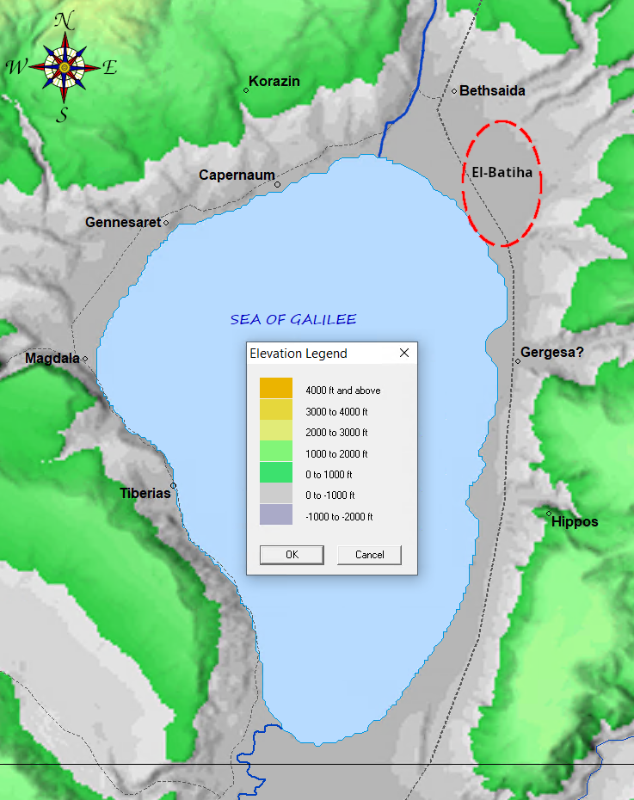Biblemapper 3.0

The “desert place” belonging to the city called Bethsaida (Luke 9:10) that had much grass (John 6:10) where the “feeding of the 5000” most likely occurred is a short one to two mile (<1 hour) walk south of Bethsaida. Considering all of the scripturally derived geographical constraints there are no other viable candidates.
Modern pictures of the plain south of Bethsaida of Ituraea (2015)

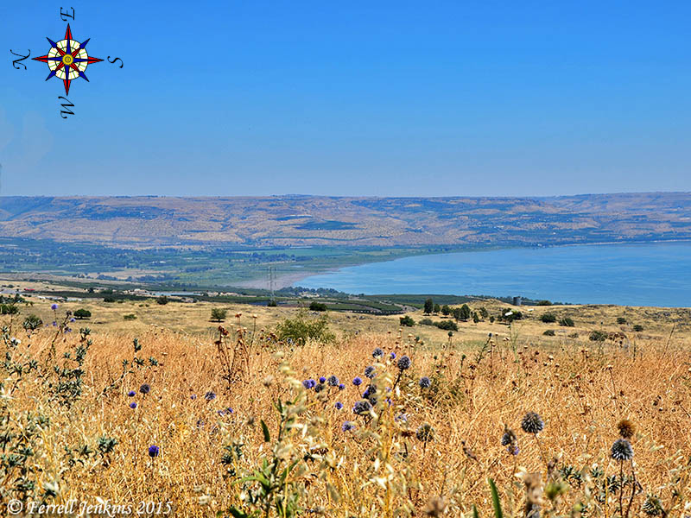

From north of Capernaum facing East we can see in the distance the fertile, alluvial plain of El-Batiha which is the same “desert place” south of Bethsaida.

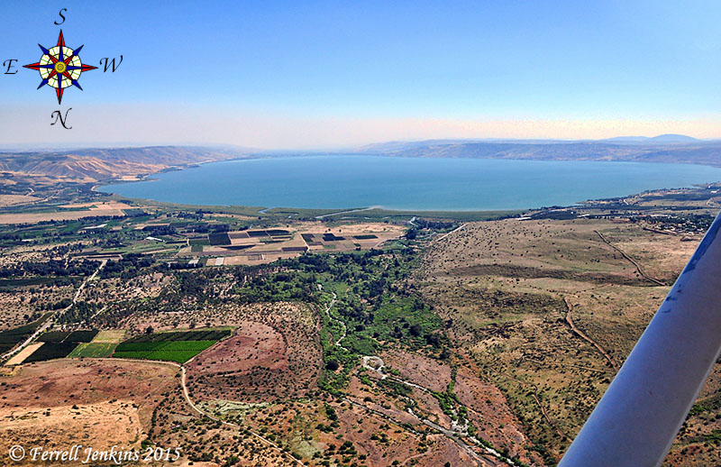

Aerial view facing south of the Bethsaida valley (El-Batiha) with the Jordan river roughly in the middle. Bethsaida is ~0.7 miles to the left/East of where this picture was taken.
So then, after the “feeding of the 5000”, when Jesus sent the disciples away before Him to Bethsaida (Matthew 14:22, Mark 6:45), why were they told to get into a ship? If they walked north it would take them less than one hour to reach Bethsaida of Ituraea (Luke 3:1).

John 6:17 tells us that their heading when they were on the sea was “toward Capernaum”. Which, no matter how we look at it is not a heading that is along the coast. Now that is interesting. Why did these disciples, 58% of which were fisherman (John 21:2,3), go far out of their way to reach a destination that was at most three miles north by foot? To help you understand why I found this very odd that long-route might look something like this:

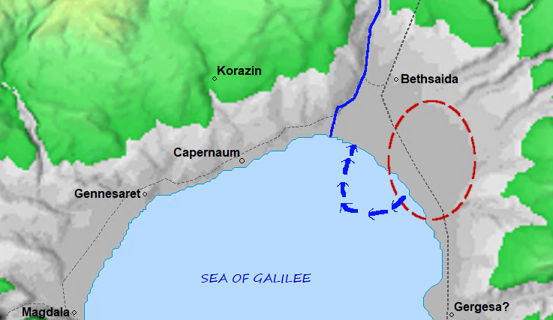

Now I’m no fisherman nor an experienced sailor; but, that route or anything like it seems very unusual. I don’t remember there being any wine at the “feeding of the 5000” and I also believe the disciples knew exactly where to go and how to get there. At least four of them were intimately familiar with navigating these waters (Mat 4:18-21).

Did Jesus send them this long way to Bethsaida so they could toil against northwest wind (Mat 14:24, John 6:17) for over 9 hours (Mark 13:35, John 6:16,17, Mat 14:25) just so that He and Peter could have a stroll on the water? Sounds odd, but I’ll admit it is a possibility (Job 5:9, Rom 11:33). Let’s see what else we can find.

A quick search for “Bethsaida” reveals 7 matches in 7 verses. Here are two of them that are very interesting:

John 1:43-44
⁴³ The day following Jesus would go forth into Galilee, and findeth Philip, and saith unto him, Follow me.
⁴⁴ Now Philip was of Bethsaida, the city of Andrew and Peter.

John 12:20-21
²⁰ And there were certain Greeks among them that came up to worship at the feast:
²¹ The same came therefore to Philip, which was of Bethsaida of Galilee, and desired him, saying, Sir, we would see Jesus.

Wherever this Bethsaida of Galilee is: Philip, Andrew, and Peter were all from the same place.

The following is a map of some of the Roman provinces around 30AD. Notice anything interesting about Bethsaida?

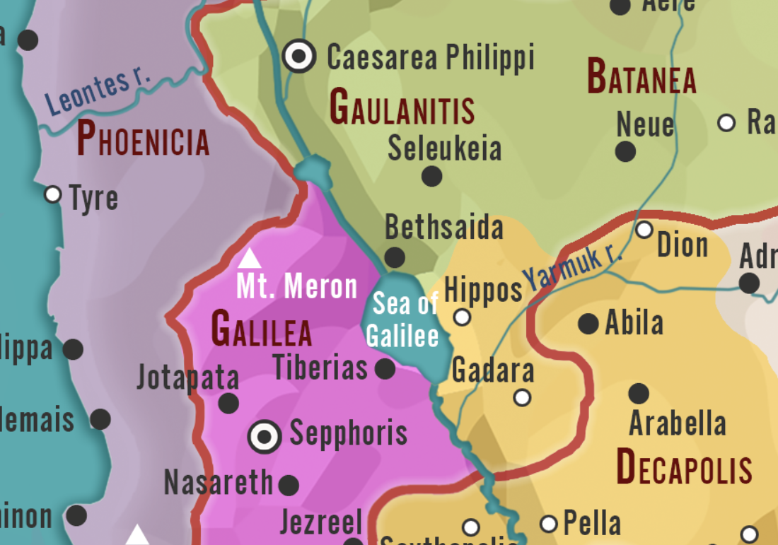World History Encyclopedia
https://creativecommons.org/licenses/by-nc/4.0/

It’s not in Galilee! But wait, didn’t we just read that Bethsaida is in Galilee? Could it be, that just like Bethlehem (Jos 19:10-15), there is more than one place called Bethsaida? And if so, where is the Bethsaida in Galilee? Let’s follow Jesus and the disciples after the “feeding of the 5000” and see if that tells us:

Matthew 14:34 (where Jesus took them)  And when they were gone over, they came into the land of Gennesaret. | John 6:15-17 (the beginning of the disciples journey across the sea)  ¹⁵ When Jesus therefore perceived that they would come and take him by force, to make him a king, he departed again into a mountain himself alone.  ¹⁶ And when even was now come, his disciples went down unto the sea,  ¹⁷ And entered into a ship, and went over the sea toward Capernaum. And it was now dark, and Jesus was not come to them.  John 6:24-25 (during and after arriving at “the land of Gennesaret”)  ²⁴ When the people therefore saw that Jesus was not there, neither his disciples, they also took shipping, and came to Capernaum, seeking for Jesus.  ²⁵ And when they had found him on the other side of the sea, they said unto him, Rabbi, when camest thou hither?
Mark 6:53 (where Jesus took them)
And when they had passed over, they came into the land of Gennesaret, and drew to the shore.

When the disciples left, they headed “over the sea toward Capernaum”. From the evening (John 6:16) until into the fourth watch of the night (Mat 14:25; ~9hrs) they toiled against the contrary northwest wind (Mat 14:24). For all that rowing they traveled far enough to reach “the other side” but instead of arriving at their destination they ended up in the middle of the sea (Mat 14:24, Mar 6:47, John 6:19).

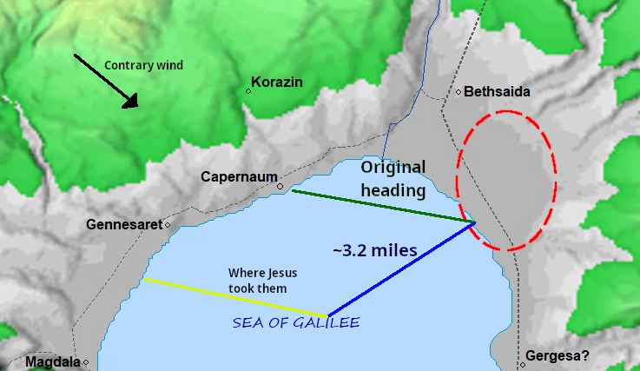
This time, instead of Jesus rebuking the boisterous wind (Mar 4:39), the wind did not cease (Mat 14:32) until they willingly received Jesus (and Peter with Him) into their ship (Mat 14:32, John 6:21). And when they did, immediately (John 6:21) the ship arrived at “the paradise of Galilee” (the land of Gennesaret) as it was so called by the historian Flavius Josephus due to it’s very fertile, well-watered land which produces an abundance of agricultural products in a relatively small area.

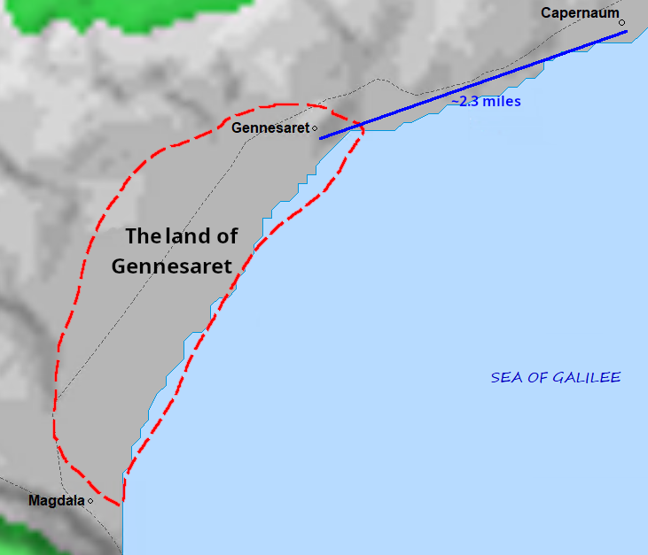

While in the land of Gennesaret word spread quickly that Jesus was there and they brought the sick and the diseased to be healed as Jesus and the disciples traveled toward Capernaum (Mat 14:34-36, Mark 6:53-56, John 6:24,25).

The people from the “feeding of the 5000” took note that the disciples had left without Jesus, and joined by more boats from Tiberias, they went to Capernaum to search for Jesus (John 6:22-24). And by the time they arrived, that is where they found Him (John 6:25).

Summary

- After the “feeding of the 5000”, Jesus constrained the disciples to go on without Him to Bethsaida.
- When the disciples left at evening they headed towards Capernaum.
- Between 3AM and 6AM the next morning, Jesus meets them in the midst of the sea of Galilee and immediately they arrive at the land of Gennesaret.
- In the land of Gennesaret, and while headed towards Capernaum, Jesus healed many sick and diseased people from the region round about.

So, where’s Bethsaida of Galilee in all of that? Did Jesus send them to some mysterious location that they never actually visited?

In John 12:21 what is the hometown of Philip, Andrew, and Peter called? Bethsaida of Galilee.

In the following verses what is the hometown of Philip, Andrew, and Peter called?

Matthew 4:12,13,17-19  ¹² Now when Jesus had heard that John was cast into prison, he departed into Galilee;  ¹³ And leaving Nazareth, he came and dwelt in Capernaum, which is upon the sea coast, in the borders of Zabulon and Nephthalim:  ...  ¹⁷ From that time Jesus began to preach, and to say, Repent: for the kingdom of heaven is at hand.  ¹⁸ And Jesus, walking by the sea of Galilee, saw two brethren, Simon called Peter, and Andrew his brother, casting a net into the sea: for they were fishers.  ¹⁹ And he saith unto them, Follow me, and I will make you fishers of men. | Mark 1:14-17  ¹⁴ Now after that John was put in prison, Jesus came into Galilee, preaching the gospel of the kingdom of God,  ¹⁵ And saying, The time is fulfilled, and the kingdom of God is at hand: repent ye, and believe the gospel.  ¹⁶ Now as he walked by the sea of Galilee, he saw Simon and Andrew his brother casting a net into the sea: for they were fishers.  ¹⁷ And Jesus said unto them, Come ye after me, and I will make you to become fishers of men.  Mark 1:21, 29-30  ²¹ And they went into Capernaum; and straightway on the sabbath day he entered into the synagogue, and taught.  ²⁹ And forthwith, when they were come out of the synagogue, they entered into the house of Simon and Andrew, with James and John.  ³⁰ But Simon's wife's mother lay sick of a fever, and anon they tell him of her. | Luke 4:31-33,38  ³¹ And came down to Capernaum, a city of Galilee, and taught them on the sabbath days.  ³² And they were astonished at his doctrine: for his word was with power.  ³³ And in the synagogue there was a man, which had a spirit of an unclean devil, and cried out with a loud voice,  ...  ³⁸ And he arose out of the synagogue, and entered into Simon's house. And Simon's wife's mother was taken with a great fever; and they besought him for her.

When they left the synagogue** in Capernaum their next stop was necessarily a house in the same town because of sabbath day walking restrictions. So, either Philip, Andrew, and Simon were originally from Bethsaida of Galilee and then they all decided to move to Capernaum … or both Capernaum and Bethsaida of Galilee are two different names for the same location***. I submit to you that the latter is the case.

English | 1524 Bomberg MT | Meaning
Beth- | בֵּית | “House” or “place”
-saida | צַיְדָה | “fishing”, “hunting”, or “providing food”
-lehem | לֶחֶם | “bread”, “feeding”, “consuming”

“Beth-saida” is a very fitting name for the place that the Bread of life (John 6:48), born in the “house of bread” (Beth-lehem), chose to first cast His net* (Mat 4:18-21).

* Andrew and an unnamed disciple are the first recorded to voluntarily follow Jesus (John 1:35-40). Simon then meets Jesus (John 1:42) but is not explicitly called (commanded to follow) until after John the Baptist is put into prison (Mark 1:14). Therefore, Philip was the first disciple to be called (John 1:43). We don’t know precisely where that occurred. We only know that it was somewhere in Galilee (John 1:43).

** Sabbath walking restrictions means that everyone present lived/temporarily resided within ~0.6 miles (~3300ft.) of that synagogue: Jesus, Andrew, Simon, James, and John. And since Philip was called to follow Jesus before the events of Mark 1:17, and we are never told that he went anywhere else: he was also very likely present in Mark 1:29.

*** The center of the city of Capernaum is ~ 1/10th of a mile (~528ft.) away from the shore. This makes a lot of sense when you think about both the logistics of the fishing industry like that of Zebedee (Mark 1:20) and the fact that the processing of those products would be undesirable in the city proper. You definitely want that place down wind. Thus, we have two names for the same general place: Capernaum for the city proper and the “house of fishing” (Beth-saida) on the shore.

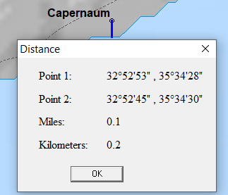

Modern day view of Capernaum

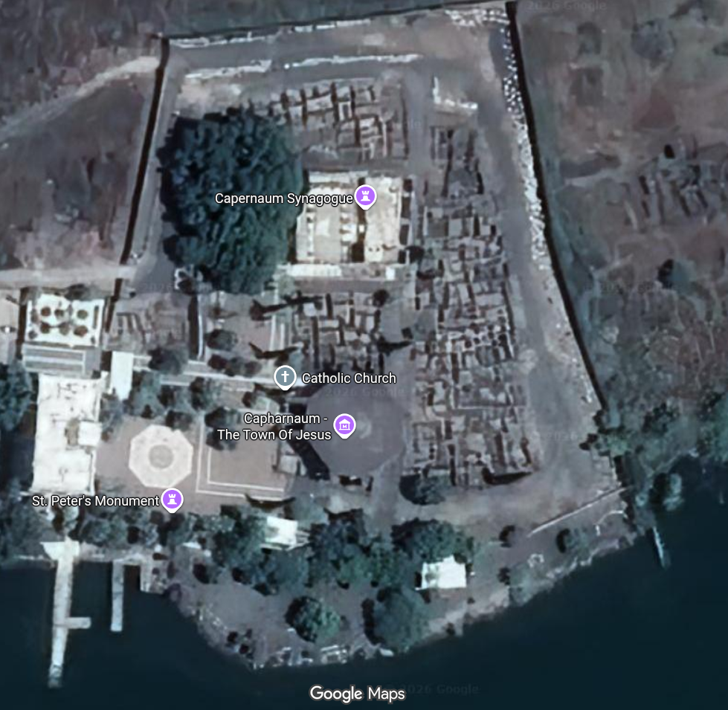

“Be of good cheer; it is I; be not afraid”
(Mat 14:27, Mark 6:50, John 6:20)

English | Transliteration | Meaning
Caper | כְּפַר Kephar (village) | “to cover”, “to shelter”
-naum | נַחוּם Nachum (of Nahum) | “comfort”, “consolation”, or “compassion”

